The <egXML>s from Faust

11.3.4.4 Confirmation, Cancellation, and Reinstatement of Modifications
Concerning passage: “In a draft version of Goethe’s Faust, a passage was struck through once in pencil during one revision and then again with ink during a later revision, supposedly to confirm the deletion.” (including Figure 13)
Should be deleted.
OK
Concerning passage: “A writer may also indicate”.
Should read: “A writer may indicate”.
OK
Concerning passage: “The redo element might be used to encode the Faust example above as follows:” (including the following egXML)
Should be deleted.

OK. We still need an example though.

11.7 Changes
Concerning passage: “In the following example … four distinct changes.”
Should read: “In the following example an editor has identified four distinct changes:”
OK
Concerning passage: the following egXML.
- “by a writer” should read “by a scribe”
- “in Goethe’s hand” could simply read “in the author’s hand”
- “revisions by Goethe” could simply read “revisions by the author”

OK. Reworded more generically
Concerning passage: “In the Faust example above”.
Should read: “In the example above”.
OK.
Concerning passage: “The above markup indicates … happened at the second stage.” Should read: Note that a change, once assigned to an element, is inherited by all descendants of that element unless overridden by a subsequent assignment.
Hmmm. I dont like this proposal because a change is not “assigned” to an element: rather, the event indicated by a piece of markup is associated with a change. Are you saying anything more than that, in the absence of any other indication, it's assumed that all the children of an element which is associated with some change are to be associated with the same change?

So in the example above the whole sentence or line was realized in the first stage, while the substitution of “house” with “mouse” happened at the second stage. In the case of <del> however, the principle of inheritance undergoes a modification: the deletion of “house” is assigned to the second stage, whereas the deleted word “house” still belongs to the first.

I don't see that there is any modification of the inheritance principle here. It's the substitution (and hence its contents) that are being assigned to a different change. Obviously the word that was deleted must have existed before it was deleted at the second stage, but that doesnt mean it “still belongs to the first” in any meaningful sense.

Here's my proposed revision for the whole passage. I've tried to start with a simpler version.

… If a <gi>change</gi> element is associated with some
element, it is also associated with all of that element's
children, unless otherwise indicated for example by a new value
for the <att>change</att> attribute. </p>
<p>In the following simple example, the text at one stage read <q>This
is a mouse</q>, and at the next <q>This is a house mouse</q>:

<egXML xmlns="http://www.tei-c.org/ns/Examples">
<line change="#firstStage">This is a
<add change="#secondStage">house</add>
mouse.</line>
</egXML>
</p>
<p>In this example, however, the text originally read <q>This is a
house</q>, and subsequently <q>This is a mouse</q>:

<egXML xmlns="http://www.tei-c.org/ns/Examples">
<line change="#firstStage">This is a <mod type="subst" change="#secondStage">
<del>house</del>
<add>mouse</add>
</mod>.</line>
</egXML>
Note that in this case both the deletion and the addition are
associated with the second stage. The word <q>house</q>, because it was deleted at the second
stage, must have been present at the first stage, whereas the word
<q>mouse</q> must have been added during the second stage. </p>

Concerning passage: “A more complex and complete example:”
Should read: It is self-evident that sentences and lines are always written down first, and altered only later. Even if <del>, <add> and the like are used in combination, the chronological order of alterations can be inferred; see section “11.3.3.2 Use of the gap, del, damage, unclear, and supplied Elements in Combination”. An explicit differentiation between changes is more useful where it is possible to divide the totality of alterations of a text into distinct groups which, for example, followed each other in time, as is the case in the manuscript that contains Goethe’s ‘Helena of 1800’:
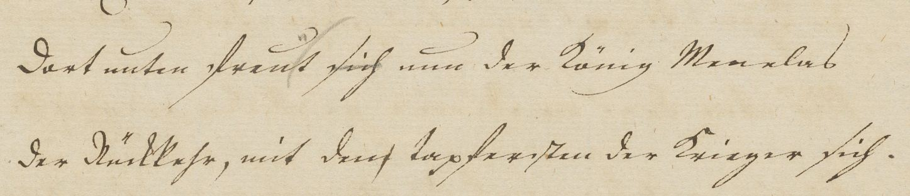
In each line occur alterations. Their belonging to different phases of the writing process may be indicated in the following way:
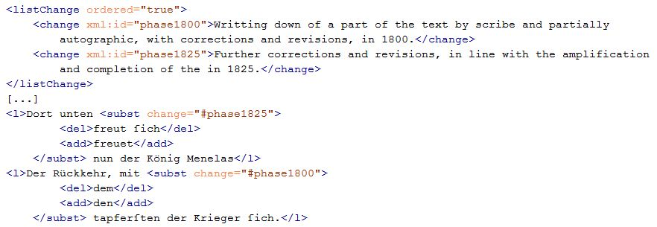
(Datei xml/egXML/differentChanges.xml)

I assume this example is meant to replace the existing” Ihr wanſtige Schuften mit den Feuerbacken” one? Fine by me, but it needs some tidying up. I will see what I can do.

Concerning passage: “Note first that a change … fixated as a whole in the third.”
Should be deleted.
I dont understand your footnote, but I am happy to remove this para if we are also removing the example which precedes it

Concerning passage: The following <egXML>. It has some inconsistencies but may remain as it is for now.
OK.

Concerning passage: “and makes no assumptions about the order of writing”.
Should be deleted.

I've toned down the sentence rather than deleting it:
From the textual perspective, the markup concentrates simply on the existence of textual alterations and makes no explicit claims about the order of writing.

Concerning passage: “which has the merit of not confusing the presentation of the interventions concerned with writing sequence information”.
Could be deleted.

I have deleted the whole sentence “In this example... intervention” since, as you note, it just isn't true of the example.

Other proposals and doubts
Ch. “11.3.1.6 Cancellation of Deletions and Other Markings” and ch. “11.3.4.4 Confirmation, Cancellation, and Reinstatement of Modifications” should be merged to avoid confusion between <restore>, <undo/> and the like.

Yes, good idea, but not sure how easy that is to do.

The proposed usage of <undo/> and <redo/> still deserves attention (see Gerrit’s e-mails of November 3 and 4).

Yes, but again I am not sure what to do about that for the current draft.

The “att.global.change” status of @change is still controversial (see Gerrit’s e-mail of November 3). In short: @change and structural elements like <div> belong to very different perspectives on the text. As a consequence, instead of the principle of inheritance the assignment of a written passage to a @change would work similar to the assignment of a passage to a hand.

Clearly there are some elements for which @change doesn't make a lot of sense, but I am not sure what they might be. You seem to imply that it should be applicable only to elements which can also carry the @hand attribute, but I am not sure everyone would agree with that.

11.7 Changes. Concerning passage: “Note that asserting a specific order early on … can be made.”
Should be deleted.

I seem to remember that Fotis was rather fond of this point? But anyway I am happy to remove it since it doesn't add anything much to the discussion.,

See amendment after next.
The egXML does not comply with the definition of <redo/>, because there is no “cancelled” intervention. A “document-focussed” encoder may wish to record that there are two cancellations (by means of two <mod>s analogous to two nested <retrace>s), or that a cancellation by pencil is retraced with ink (by means of <retrace target="…"/>?). A “text-focussed” encoder may wish to record that a deletion (<del>) had been merely provisional (@type?) before it was affirmed (nothing proposed in v.2.0). We don’t have plausible use cases for <redo/> in the Faust context yet.
The egXML is rather generic anyway so the Faust context does not add to the understanding .
The principle of inheritance is preserved in the second to last amendment.
(seems incorrect)
Seems questionable, because the identifier’s only use is to give such sequence information.
Especially the sentence: “For instance deletions can only be assigned to a stage that follows the one in which the passage being deleted was written down” seems improper, because deletions can very well be directly associated with the writing process.

